# Make a 2-player car racing game!

The object of this game is for two racing cars to be raced around a circuit. If a car leaves the road it has crashed and is out of the race. The first car to reach the finishing line wins!

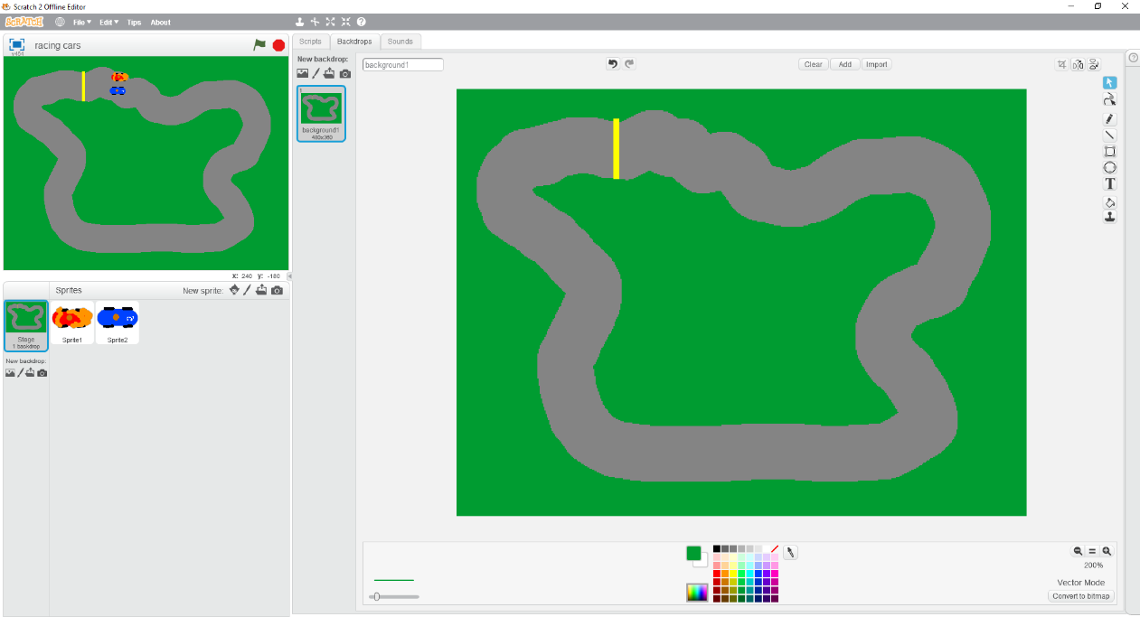**Step 1** is to start Scratch and delete the cat sprite.

**Step 2** is to change the blank stage into a race circuit. Here is the one I made.

Keep the race track one colour (I have used dark grey) and paint it using a wide paint brush.

Colour either side of the track with a single colour (I have used green) using the fill tool so it will be easy to detect when a car leaves the race track.

Finally, draw a finishing line in a single different colour using the line tool (I have chosen yellow) so you can tell when someone reaches the end.

Save your game and call it “**racing cars**”.

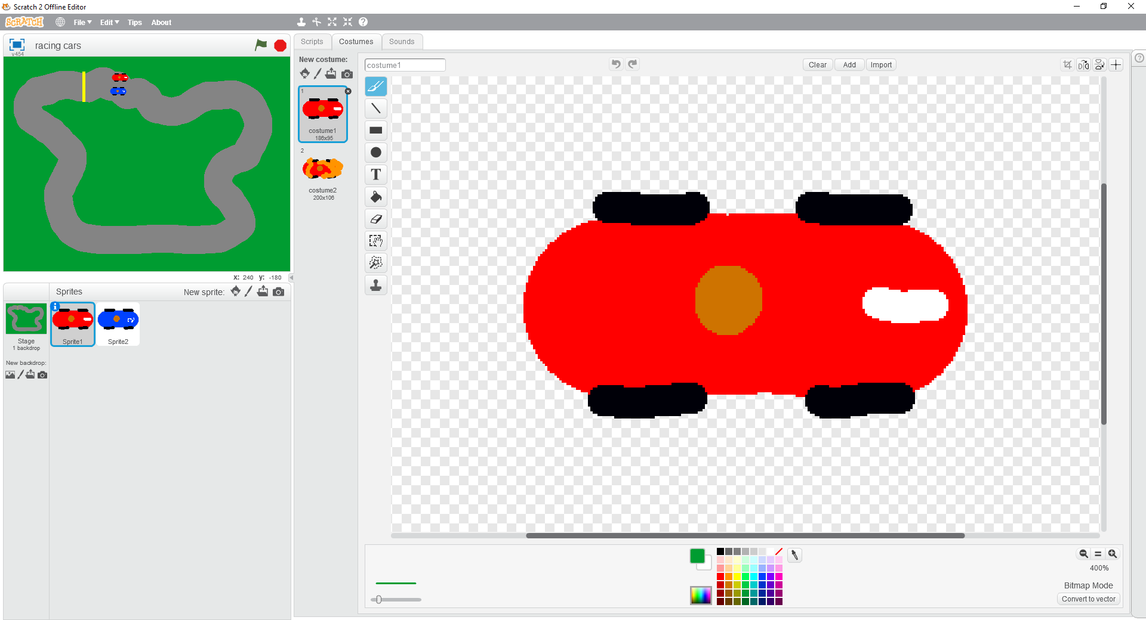**Step 3** is to make a racing car. Click the “paint new sprite” icon (which looks like a paint brush) then create a simple racing car.

Here is my one. Make sure that it is **pointing to the right** and looking at the car from above as shown - as this is the direction in which it will travel.

The car in the game will be very small so keep it simple – you can always go back and make it better later on.

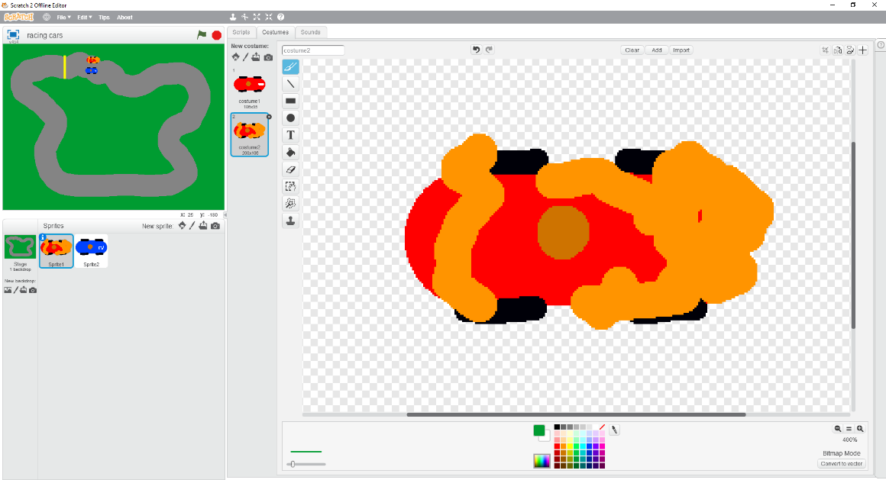**Step 4** is to make a copy of the first costume and use it to create a second costume which it will change to if the car crashes.

Here is my one. I have just drawn a lot of “stuff” over it. Keep it simple for now, you can come back later and improve it then.

Save your game so far.

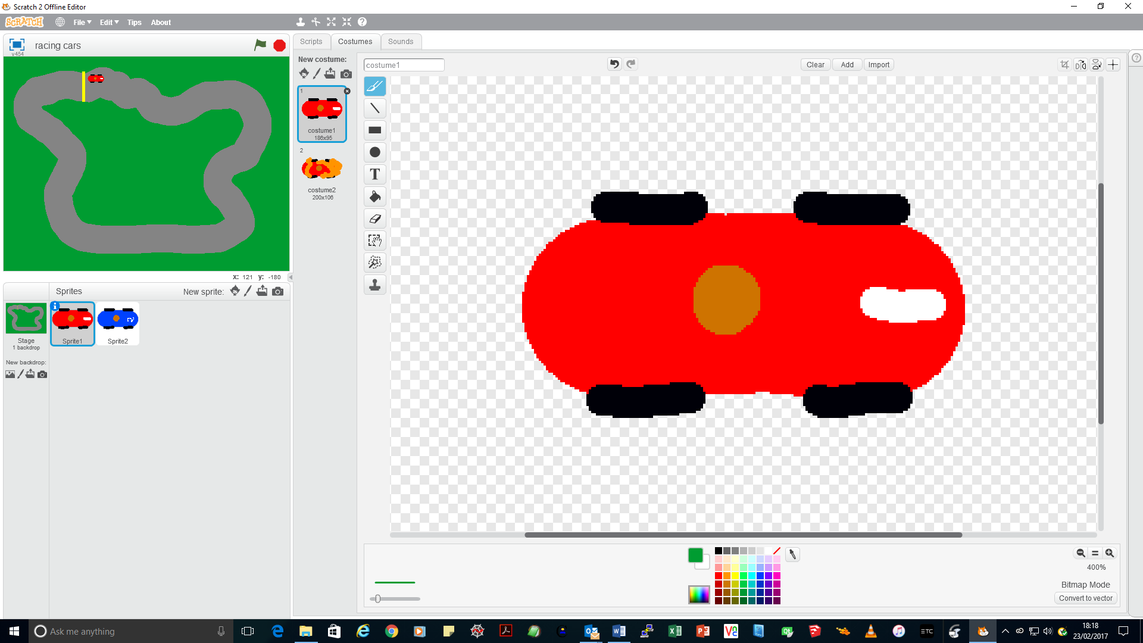**Step 5** is to select costume 1 and resize the car using the “shrink” tool (in the red circle) to fit the track so that it is small enough for another car next to it. If you haven’t done this before, click the “shrink tool” first then click the mouse on the car until it is small enough.

Move the small car to the start - which is to the right of the finish line. Here is my game so far.

**Step 6** is to write the two short scripts to make the car change direction when the left and right arrow keys are pressed.

** **

You can test them straight away using the arrow keys to make sure you can steer the car left and right.

Save your game so far.

**Step 7** is to put the car on the starting point and start the car moving using the blocks shown.

* Start when the green flag is clicked.

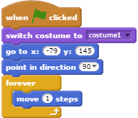

Your x and y will be different

* Always start with the not crashed car costume!
* Put the car at the starting point. As long as the car is at the starting point when you drag out the “go to x: y:” block, this will have the right coordinates for your game already.
* Point the car towards the right (+90 degrees).
* Then forever, move the car one step in the direction it is pointing.

**Step 8** is to test the game so far. You should be able to drive your car around the track. However it never crashes and it doesn’t win when it gets to the finishing line.

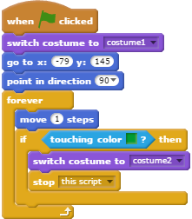**Step 9** is to detect if the car has gone off the race track.

Change the Forever block as shown – leave the rest of your code as it is!

To put the right colour into the “touching color” block, you can click inside it then move the mouse to your stage and click on the colour which is next to the race track – my one is green but your game might be different.

This bit of code checks if your car is touching the colour which surrounds your race track, which means it has gone off the track. If it has, the car changes to the crashed car costume and just this car stops moving (make sure you chose “stop this script”).

**Step 10** is to test the game again to see if the car crashes when it goes off the race track.

Save your game so far.

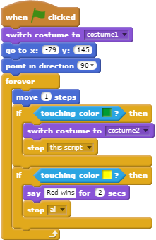**Step 11** is to detect when your car has reached the finishing line.

You do this in the same way as in Step 10 by adding three more tiles for the colour of the finishing line. Again click on the “touching color” block then click on your starting line to make sure you have the right colour. Be careful to use “stop all” this time which ends the game.

**Step 12** is to test the game which should now be complete for one car. You should be able to:

* Drive around the circuit
* Crash if you go off the track
* See a “Red wins” message if you reach the finishing line

Save your game so far.

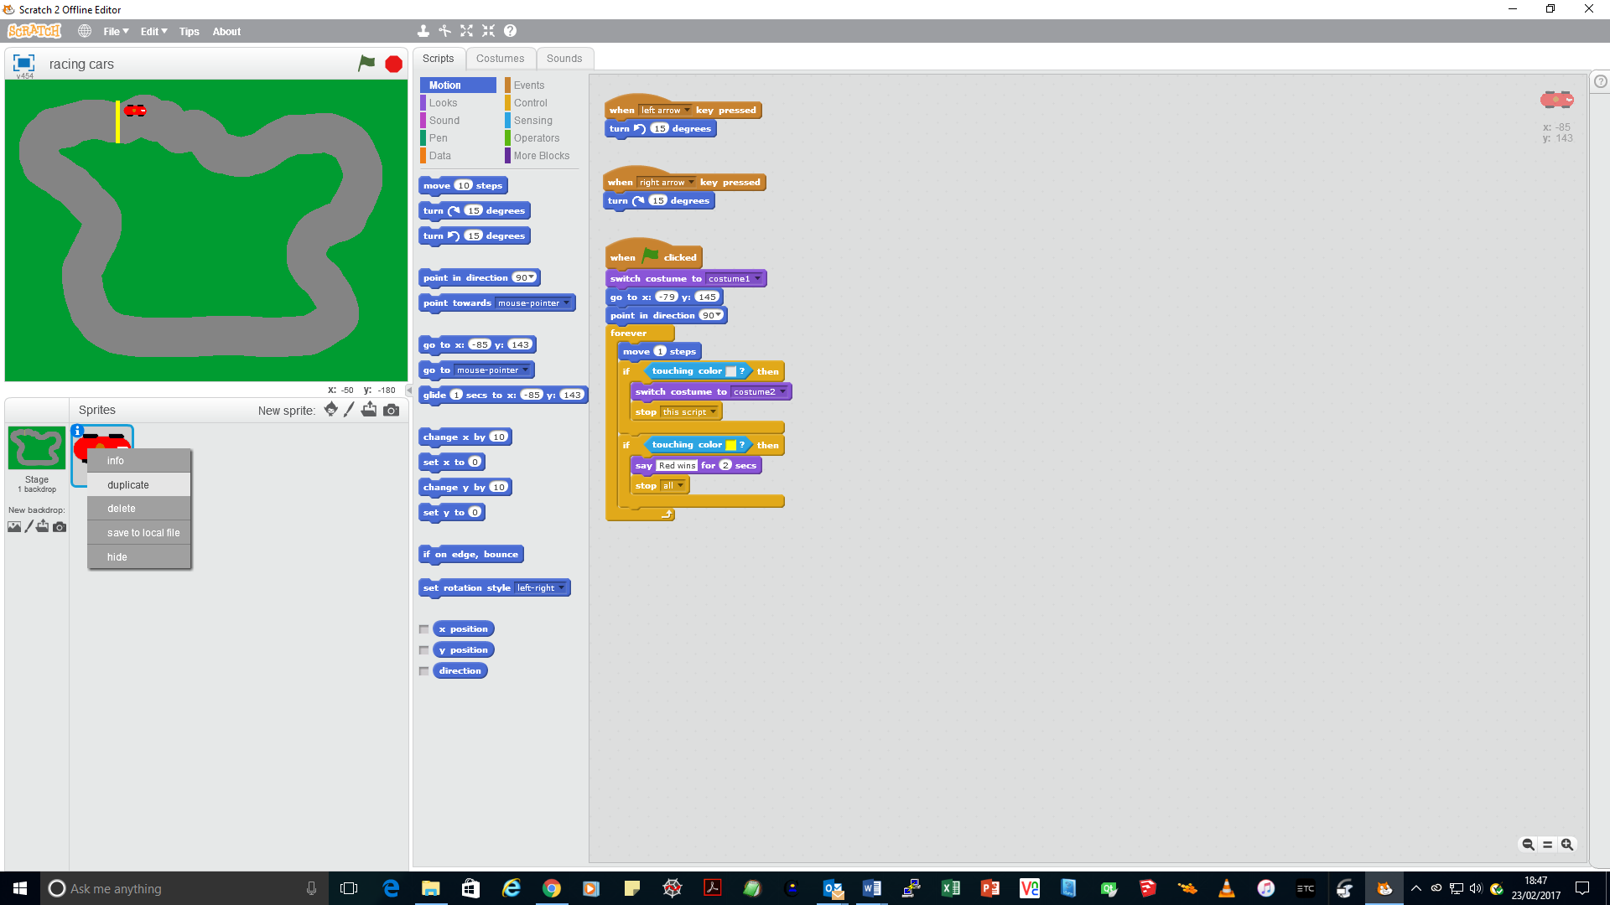**Step 12** is to add a second car. You will make a copy of the first car which will only need a few changes.

Right-click your first car and select **duplicate**. This will create sprite2 which is an exact copy of your car, including the code.

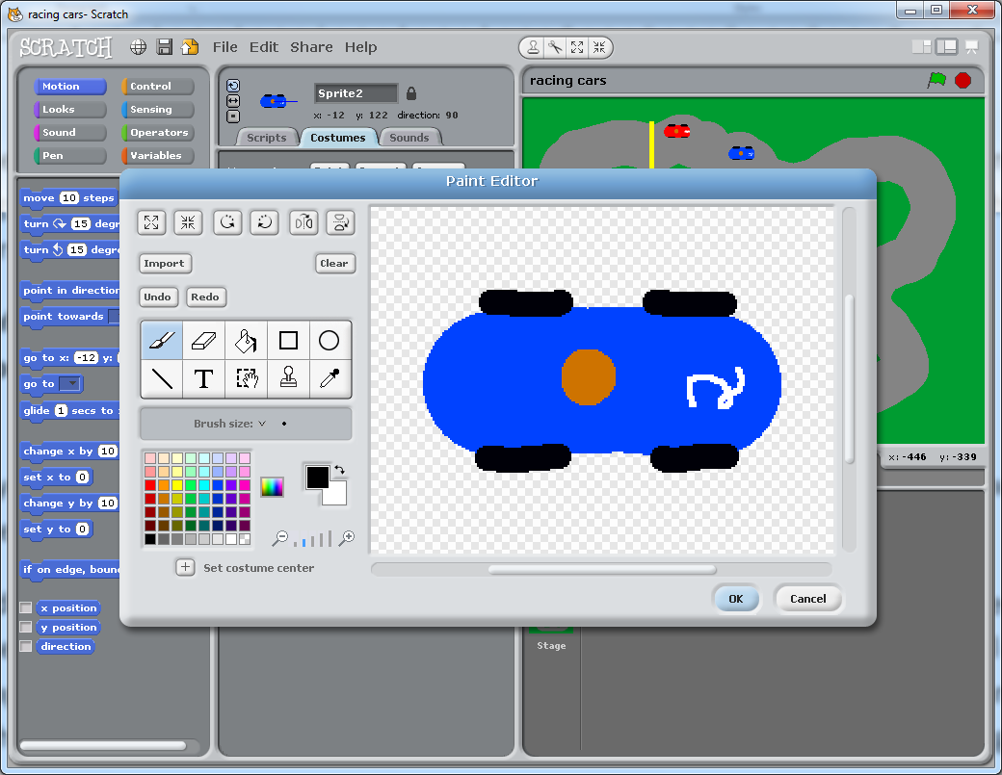Change the car colour in the two costumes – I simply filled all the red areas with blue and painted a different number on the front. Don’t forget to also update costume2 for the crashed car.

Move the second car to its starting position next to the first car on the race track.

**Step 12** is to change the code for the second car. Here is my code, I have put red arrows in to show which parts have changed.

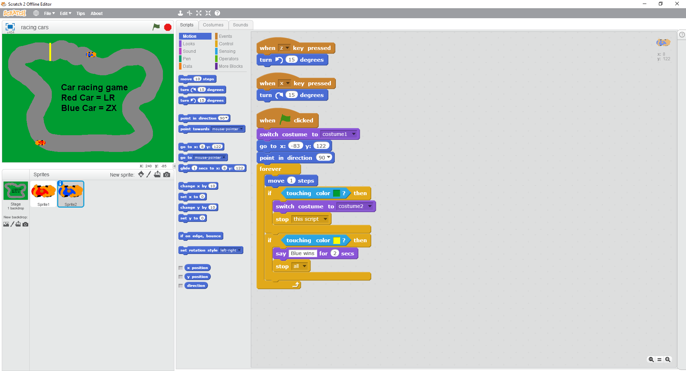

* Change the steering keys to something else, for example **left arrow** to “**z**” and **right arrow** to “**x**”. Test the two keys you have chosen steer the second car correctly.
* Take out the existing “go to” block and drag a new one out to replace it. Remember this will have the coordinates of where the car is now filled in.
* Change the message so you can tell the second car has won – “Blue car wins!” in my case.

**Step 13** is to test the final program with one of your friends to drive one of the cars. Does it work as expected?

Save your final game.

What improvements could you make?

* Can you detect if the two cars crash into each other and make a noise?
* Can you make a crash sound when the car crashes?
* Can you speed up the two cars the further they go?
* Could you add two keys to speed up and slow down?
* Something else you would like to do?